**DBMS LAB-3**

**Vinayak Prasad**

**Section 3D Batch D4**

create database bankdbms;

use bankdbms;

create table branch

(

branch_name varchar(20),

branchcity varchar(20),

Assets int,

primary key(branch_name)

);

insert into branch values('SBI_Chamrajpet','Bangalore',50000);

insert into branch values('SBI_ResidencyRoad','Bangalore',10000);

insert into branch values('SBI_ShivajiRoad','Bombay',20000);

insert into branch values('SBI_ParliamentRoad','Delhi',10000);

insert into branch values('SBI_Jantarmantar','Delhi',20000);

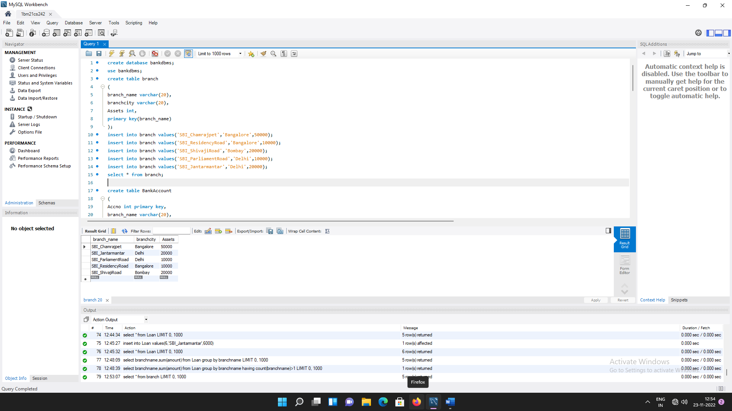select * from branch;

create table BankAccount

(

Accno int primary key,

branch_name varchar(20),

Balance real,

foreign key(branch_name) references branch(branch_name)

);

insert into BankAccount values(1,'SBI_Chamrajpet',2000);

insert into BankAccount values(2,'SBI_ResidencyRoad',5000);

insert into BankAccount values(3,'SBI_ShivajiRoad',6000);

insert into BankAccount values(4,'SBI_ParliamentRoad',9000);

insert into BankAccount values(5,'SBI_Jantarmantar',8000);

insert into BankAccount values(6,'SBI_ShivajiRoad',4000);

insert into BankAccount values(8,'SBI_ResidencyRoad',4000);

insert into BankAccount values(9,'SBI_ParliamentRoad',3000);

insert into BankAccount values(10,'SBI_ResidencyRoad',5000);

insert into BankAccount values(11,'SBI_Jantarmantar',2000);

select * from BankAccount;

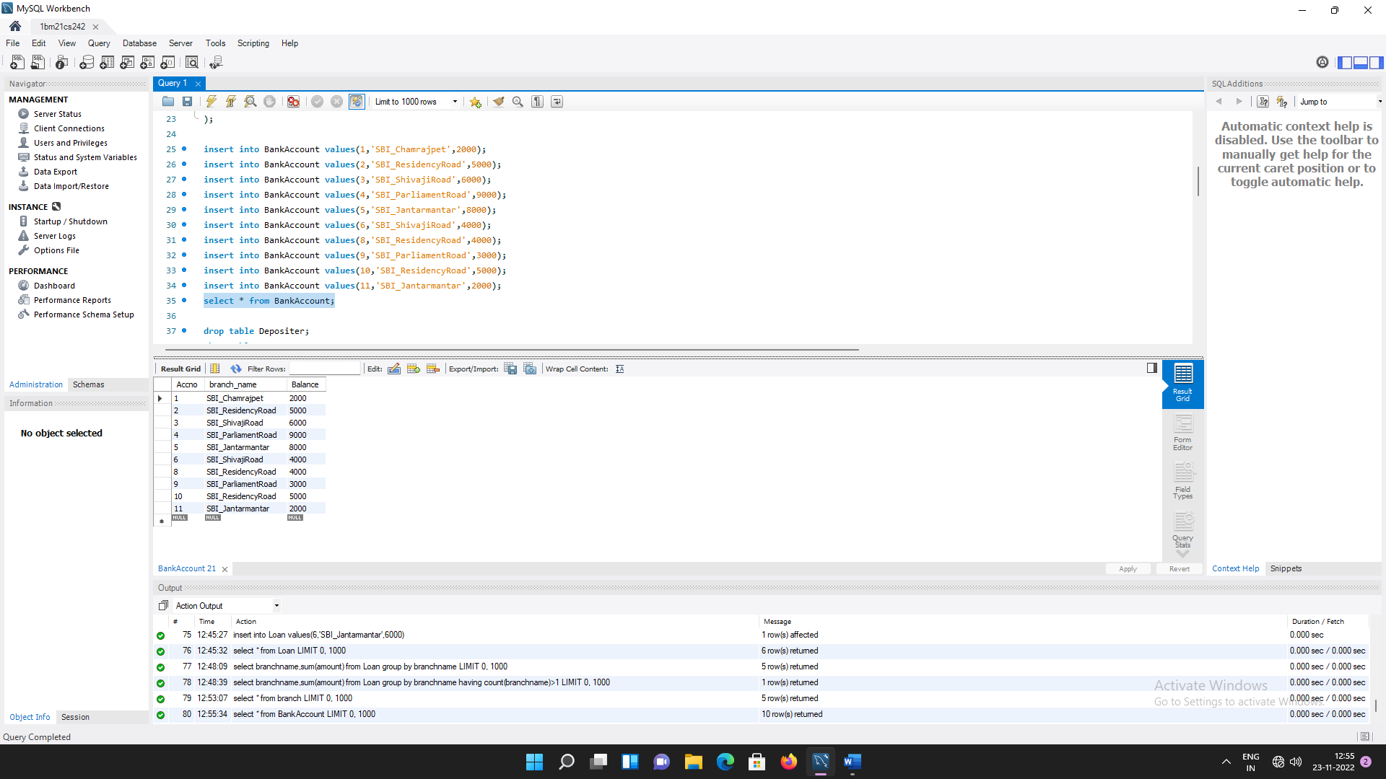

create table Depositer

(

customername varchar(20),

Accno int,

foreign key(customername) references BankCustomer(customer_name),

foreign key(Accno) references BankAccount(Accno)

);

insert into Depositer values('Avinash',1);

insert into Depositer values('Dinesh',2);

insert into Depositer values('Nikil',3);

insert into Depositer values('Ravi',4);

insert into Depositer values('Avinash',8);

insert into Depositer values('Dinesh',10);

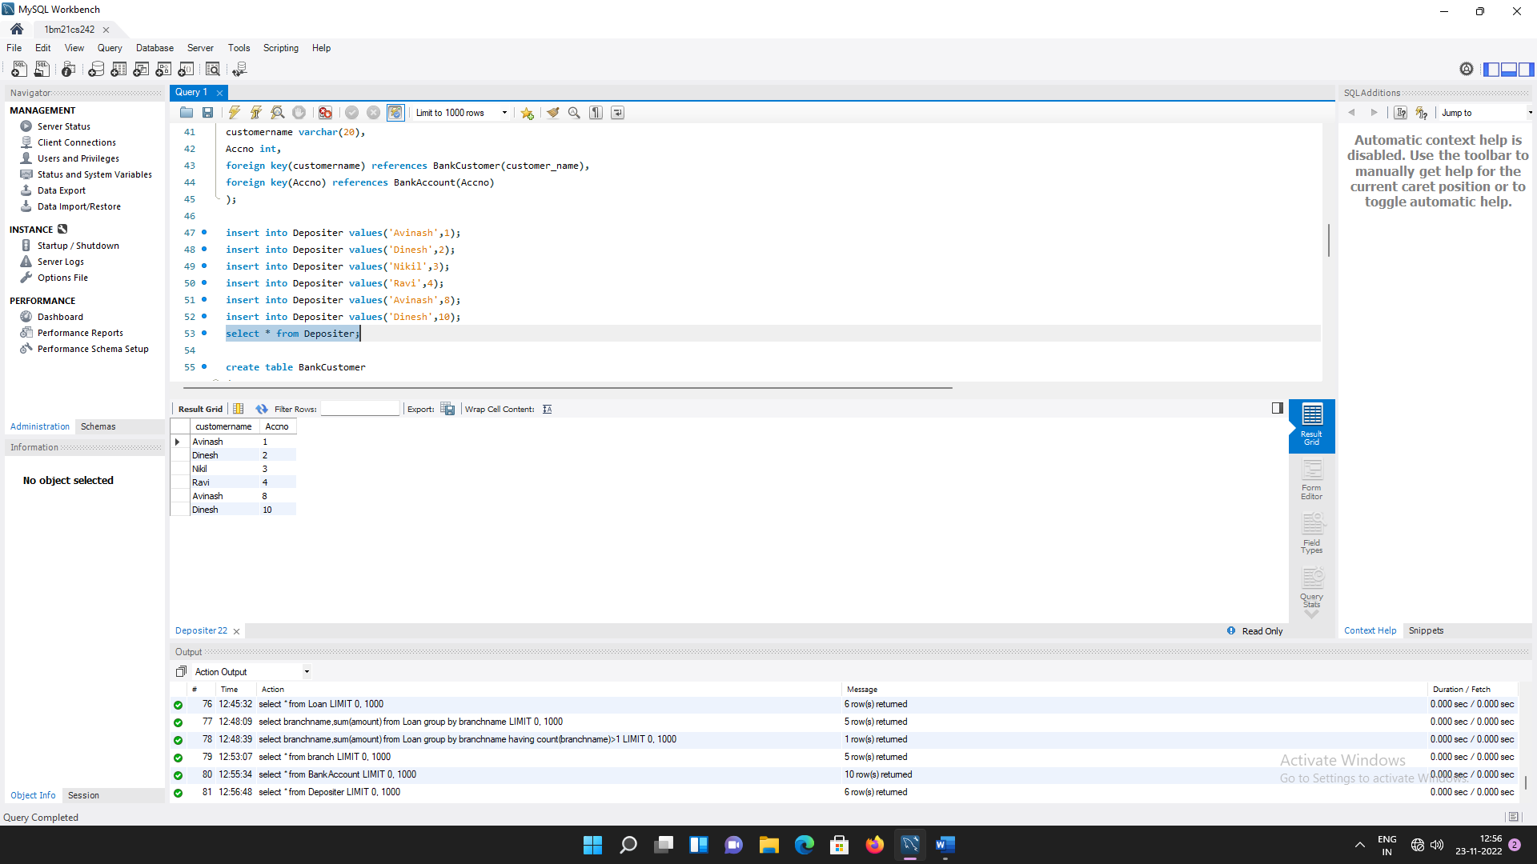select * from Depositer;

create table BankCustomer

(

customer_name varchar(20) primary key,

customer_street varchar(50),

city varchar(20)

);

insert into BankCustomer values('Avinash','Bull_Temple_Road','Bangalore');

insert into BankCustomer values('Dinesh','Bannergatta_Road','Bangalore');

insert into BankCustomer values('Mohan','NationalCollege_Road','Bangalore');

insert into BankCustomer values('Nikil','Akbar_Road','Delhi');

insert into BankCustomer values('Ravi','Prithviraj_Road','Delhi');

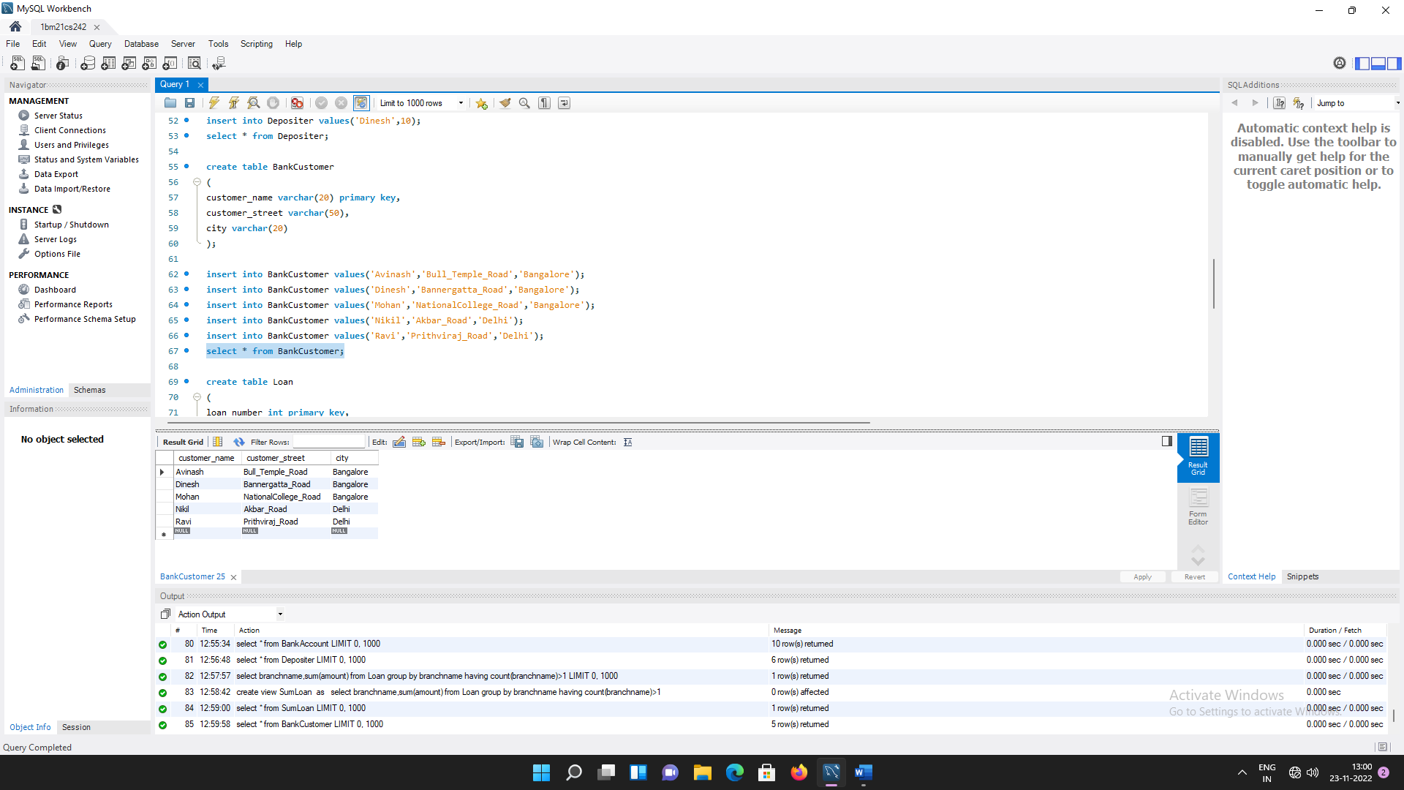select * from BankCustomer;

create table Loan

(

loan_number int primary key,

branchname varchar(20),

amount real,

foreign key(branchname) references branch(branch_name)

);

insert into Loan values(1,'SBI_Chamrajpet',1000);

insert into Loan values(2,'SBI_ResidencyRoad',2000);

insert into Loan values(3,'SBI_ShivajiRoad',3000);

insert into Loan values(4,'SBI_ParliamentRoad',4000);

insert into Loan values(5,'SBI_Jantarmantar',5000);

insert into Loan values(6,'SBI_Jantarmantar',6000);

select * from Loan;

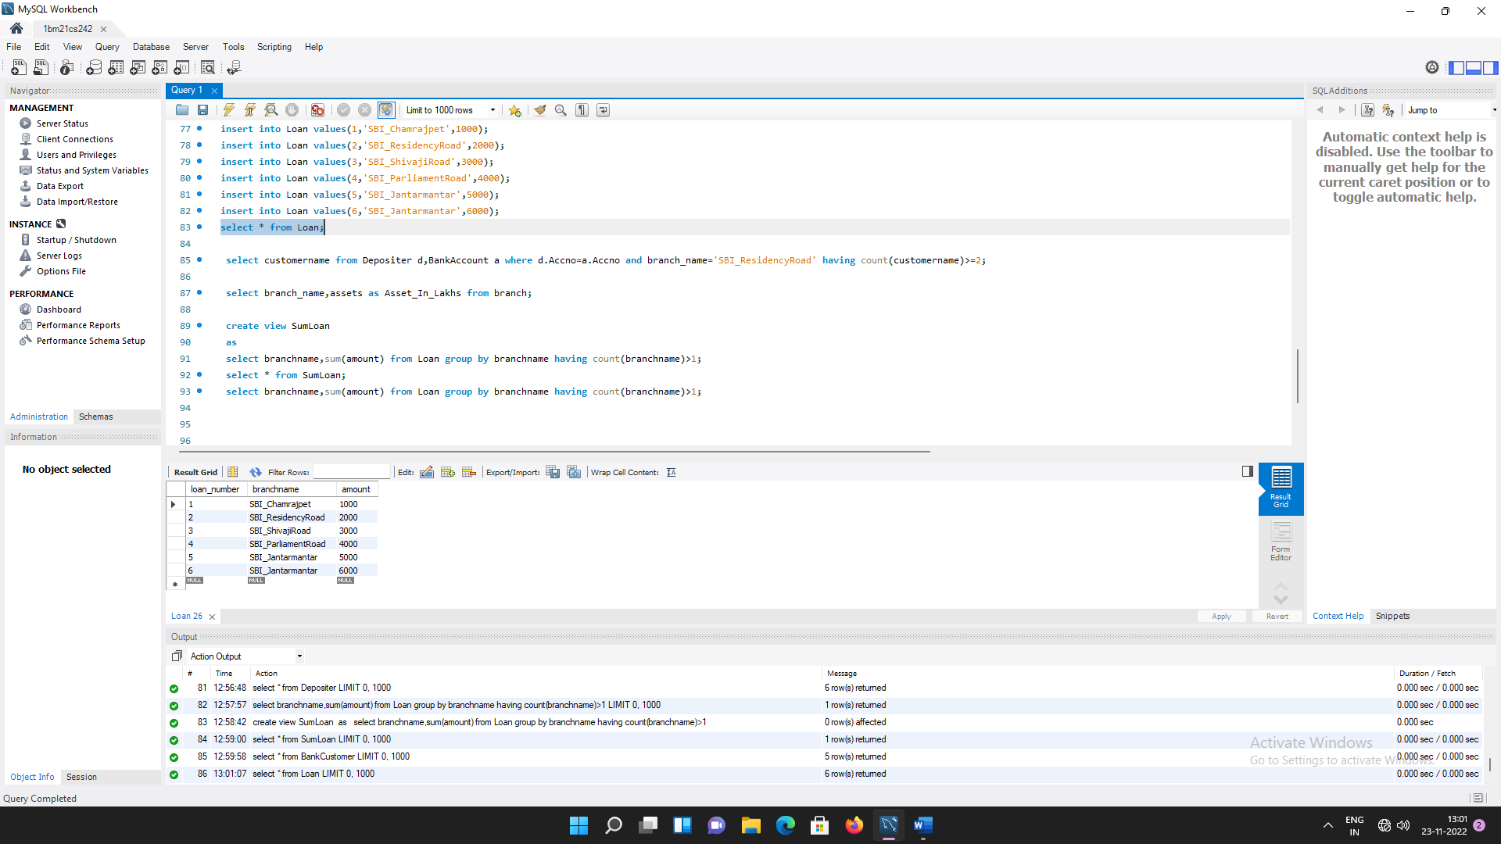

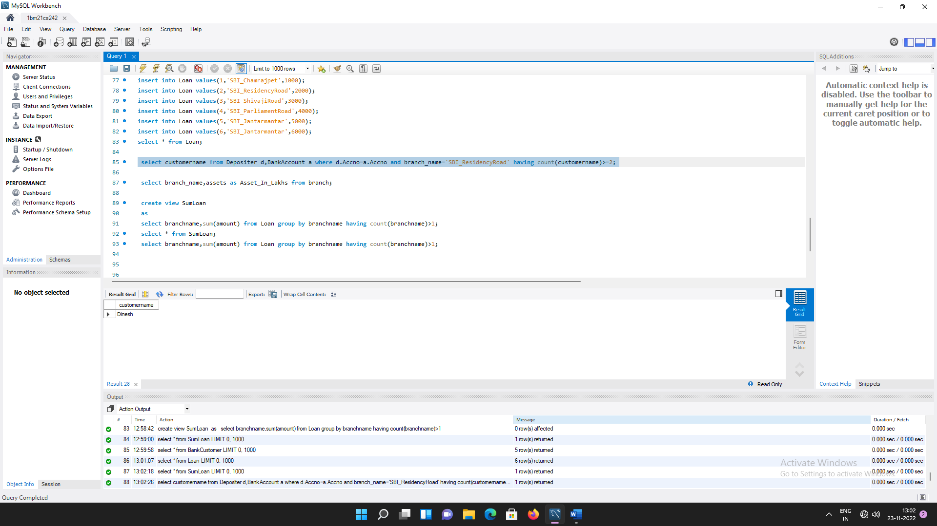select customername from Depositer d,BankAccount a where d.Accno=a.Accno and branch_name='SBI_ResidencyRoad' having count(customername)>=2;

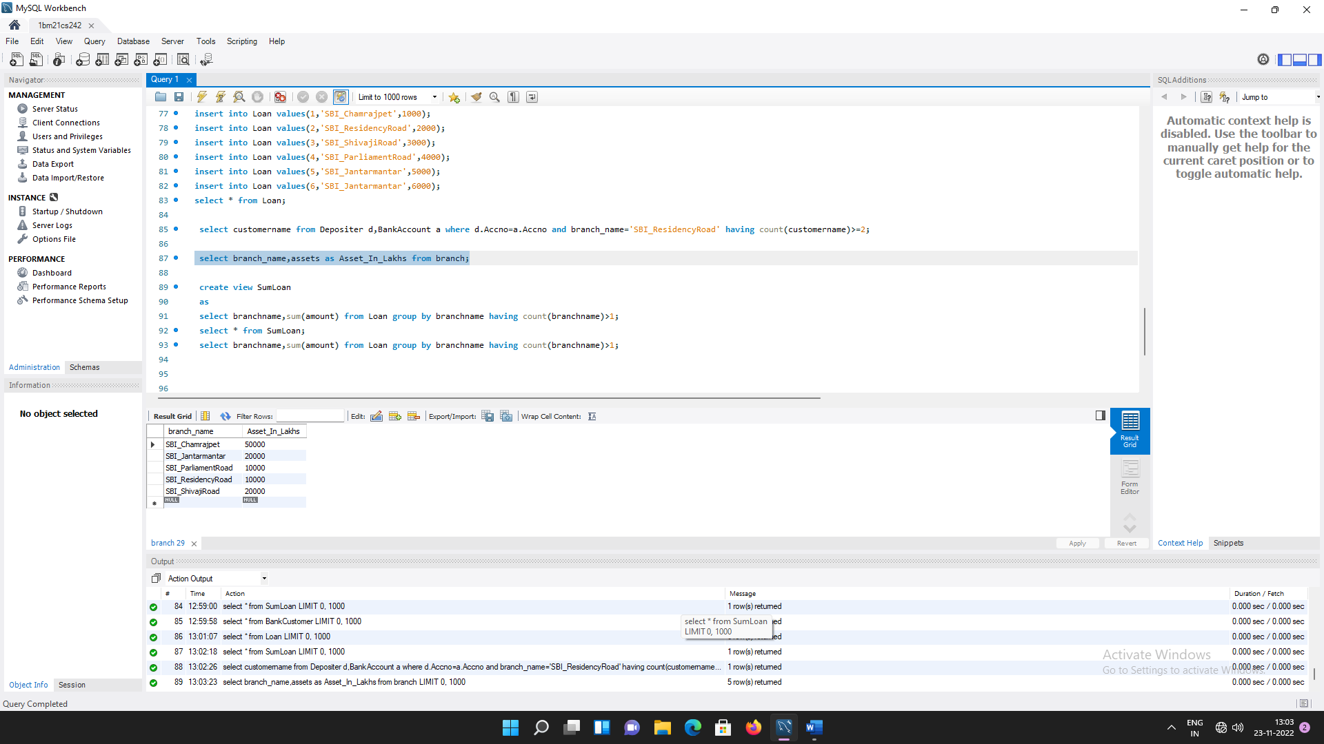select branch_name,assets as Asset_In_Lakhs from branch;

create view LoanBranch

as

select branchname,sum(amount) from Loan group by branchname;

select * from LoanBranch;

